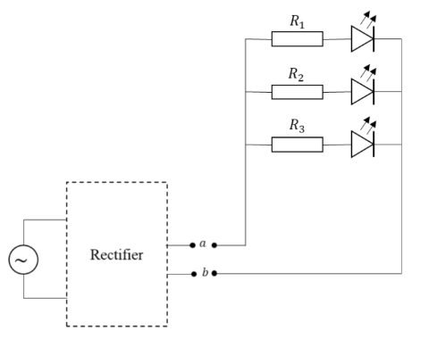
You are planning to conduct a small electronic project. You are planning to make a simple LED circuit (see diagram). The circuit contains three green LED lights that connect using parallel connections. From the LED specification sheet, you know that the LED will work on a minimum voltage of 2V. Also, you gain information that the LED will break if the current that flows through it exceeds 20mA. For that, you need to use some resistor to limit the current that flows through the LED.
Figure 1: RLC circuit from the Case Study Problem
To power the circuit, you are planning to use a micro hydro generator that you already have. However, you realize that you need to convert the current from AC to DC so you can light up the LED. But you don’t have the proper converter now. So, you decide to make your own rectifier, a basic RLC rectifier, from only the components you have (see table) at hand. Assume that your component supply is large enough, so you can use any number of each component.
Assume that your LED does not have any internal resistance. The LED circuit will be connected to the rectifier at point a and b (see diagram). The generator has an output of 5V with a frequency of 20Hz. So, what is your solution for the basic RLC rectifier? Assume that each component on the table (including the EMF) has an internal resistance of 0.1Ω.

a. Topology plan for the RLC rectifier circuit
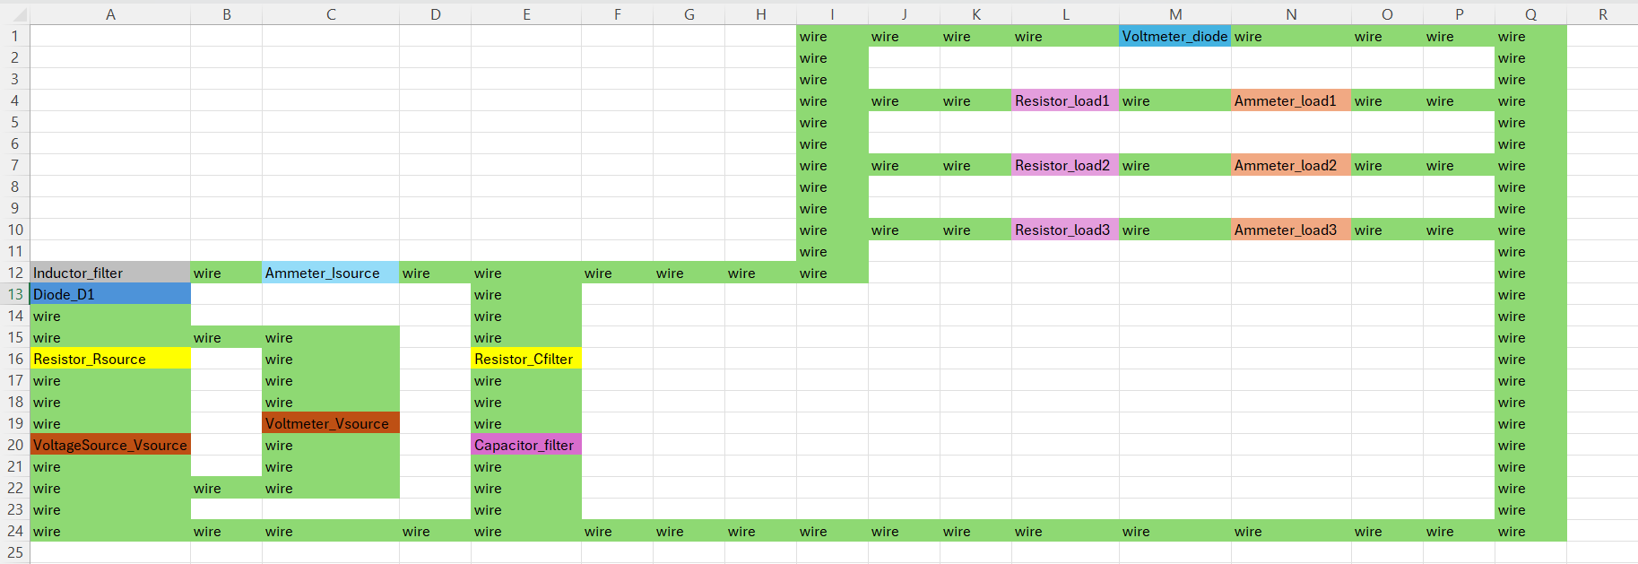

b. Explanation of the reason you chose the component set.
No. | Component | Reason
1. | Voltage Source | A 5V AC source is specified as the power supply.
2. | Diode | Diodes are used in rectification to convert AC to DC.
3. | Resistor | Resistors are used to limit the current to each LED.
4. | Capacitor | Capacitor reduces ripples and providing more stable DC voltage.
5. | Inductor | Inductor acts to smoothen the DC output by attenuating high-frequency components in the rectified signal.
6. | Voltmeter | Voltmeter can monitor the input voltage
7. | Ammeter | Ammeter used to measure the current in a circuit.

c. Value of each of the components used, including the numerical reason why this setting will work.
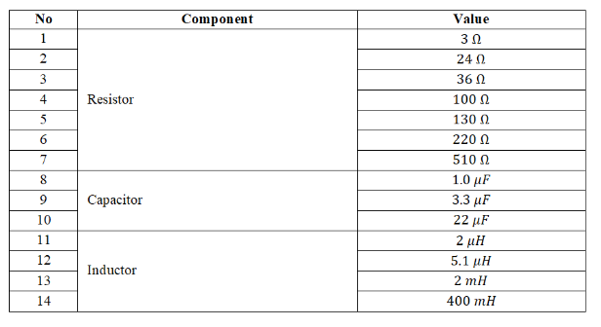
Minimum voltage (V_{min}): 2V | Maximum current (I_{max}): 20mA
Generator output (V_{gen}): 5V | Frequency (F): 20 Hz
Internal Resistance: 0.1Ω

- Peak Voltage
$$Vpeak=Voutput* \sqrt{2}=5* \sqrt{2}=7.071V$$

- Current for Each Resistor Value
- R = 3Ω
$I=\frac{V}{R}=\frac{7.071}{3}=2.36A=2,360$mA (Exceeds 20mA, unsuitable)
- R = 24Ω
$I=\frac{V}{R}=\frac{7.071}{24}=0.295A=295mA$ (Exceeds 20mA, unsuitable)
- R = 36Ω
$I=\frac{V}{R}=\frac{7.071}{36}=0.196A=196mA$ (Exceeds 20mA, unsuitable)
- R = 100Ω
$I=\frac{V}{R}=\frac{7.071}{100}=0.071A=71mA$ (Exceeds 20mA, unsuitable)
- R = 130Ω
$I=\frac{V}{R}=\frac{7.071}{130}=0.054A=54mA$ (Exceeds 20mA, unsuitable)
- R = 220Ω
$I=\frac{V}{R}=\frac{7.071}{220}=0.032A=32mA$ (Exceeds 20mA, potentially risky)
- R = 510Ω
$I=\frac{V}{R}=\frac{7.071}{510}=0.014A=14mA$ (Falls below 20mA, suitable)

- Capacitor Value
To choose the best capacitor from the available options, we need to understand that the goal is to reduce the ripple in the rectified DC signal. The higher the capacitance, the better it can smooth the ripple, as it stores more charge and releases it to stabilize the voltage during the gaps in the rectified waveform.
- 1μF and 3.3μF capacitors are relatively small, and while they would help with smoothing, they may not be sufficient to reduce the ripple to an acceptable level for the LED circuit.
- 22μF, on the other hand, is the largest capacitor available. While it's smaller than the ideal value, it is still large enough to provide some degree of smoothing.
Among the available options, 22μF is the largest capacitor. While a larger capacitance would provide even more effective smoothing, 22μF is the best option given the available components. It will provide the most significant ripple reduction compared to the smaller capacitors (1μF and 3.3μF), which would not be able to smooth the signal as effectively. Assume that we are using multiple capacitors to reduce the ripple. For my case, I’ll try to use any number that is lower than 1000. (Final: 900)

- Inductor Value

d. Modeling output graphs using Python Power Electronics to prove that setting comply to the minimum voltage and maximum current requirements.
- Original Value → Modified Value
No. | Component | No. | Component
1 | Component type: Ammeter  Component name: Isource  Component position: 1C  Positive direction of current: 1D  (Clockwise) | 2 | Component type: Ammeter  Component name: load1  Component position: 5F  Positive direction of current: 4F → 6F  (Clockwise)
3 | Component type: Ammeter  Component name: load2  Component position: 5I  Positive direction of current: 4I → 6I (Clockwise) | 4 | Component type: Ammeter  Component name: load3  Component position: 5L  Positive direction of current: 4L → 6L (Clockwise)
5 | Component type: Capacitor  Component name: filter  Component position: 7Q  Capacitor value: 0.0176  Positive polarity: 6Q  (Counterclockwise) | 6 | Component type: Diode  Component name: D1  Component position: 2A  Voltage level: 120.0 → 1000.0  Direction of cathode: 1A (Counterclockwise)
7 | Component type: Inductor  Component name: filter  Component position: 1A  Inductor value: 0.001 → 0.002 (Inductor used 2mH) | 8 | Component type: Resistor  Component name: Cfilter  Component position: 5Q  Resistor value: 100.0 → 0.1 (Assume from instruction)
9 | Component type: Resistor  Component name: Rsource  Component position: 5A  Resistor value: 100.0 → 0.1 (Assume from instruction) | 10 | Component type: Resistor  Component name: load1  Component position: 7F  Resistor value: 100.0 → 510.0 (Resistor used 510 Ω)
11 | Component type: Resistor  Component name: load2  Component position: 7I  Resistor value: 100.0 → 510.0 (Resistor used 510 Ω) | 12 | Component type: Resistor  Component name: load3  Component position: 7L  Resistor value: 100.0 → 510.0 (Resistor used 510 Ω)
13 | Component type: VoltageSource  Component name: Vsource  Component position: 9A  Peak value: 120.0 → 7.071 (Voltage used 7.071V)  Frequency: 60.0 → 20.0 (Frequency from instruction)  Phase angle: 0.0  Dc offset: 0.0  Positive polarity: 8A (Clockwise) | 14 | Component type: Voltmeter  Component name: Vsource  Component position: 7C  Voltage level: 120.0 → 1000.0  Positive direction of voltage: 6C (Counterclockwise)
15 | Component type: Voltmeter  Component name: diode  Component position: 7O  Voltage level: 120.0 → 1000.0  Positive direction of voltage: 6O (Counterclockwise)

- Simulation Plot
  - First Plot: Current
    - Waveform source: Ammeter_load1
    - Waveform legend: iload_1

    - Waveform source: Ammeter_load2
    - Waveform legend: iload_2

    - Waveform source: Ammeter_load3
    - Waveform legend: iload_3
  - Second Plot: Voltage
    - Waveform source: Voltmeter_vsource
    - Waveform legend: vsource

    - Waveform source: Voltmeter_diode
    - Waveform legend: vload
  - Third Plot: All
    - Waveform source: Ammeter_load1
    - Waveform legend: iload_1

    - Waveform source: Ammeter_load2
    - Waveform legend: iload_2

    - Waveform source: Ammeter_load3
    - Waveform legend: iload_3

    - Waveform source: Voltmeter_vsource
    - Waveform legend: vsource

    - Waveform source: Voltmeter_diode
    - Waveform legend: vload

    - Waveform source: Ammeter_Isource
    - Waveform legend: isource

- adada

